Polysaccharides

These are polymers of sugar units.
This means that they need to be broken apart into single sugars before they can be used in respiration.
They are all insoluble, as if they were dissolved in the cytoplasm, water would be drawn into cells, causing the cells to swell and burst, destroying the cells. The insoluble polysaccharides do not affect osmosis, so are good for storage in organisms.
These are all polymers of α-glucose.

Starch

This is the energy storage molecule in plants.
It is found as granules in the cytoplasm of cells.
Starch is made up of two different polysaccharides, amylose and amylopectin.
These are formed from glucose, and the resulting molecules can be hydrolysed to re-form glucose.

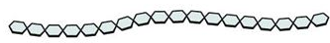
Amylose:
- Makes up 20-30% of starch.
- This is a chain polymer joined by 1-4 glycosidic bonds.
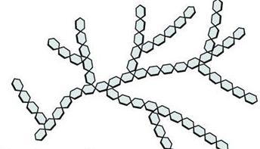
- Because of the bond angles, amylose has a coiled shape, making it very compact. This means it is an excellent storage molecule.

Amylopectin:
- Makes up 70-80% of starch.
- This is a branched polymer joined by 1-4 glycosidic bonds, but where a branch is joined, the bond is a 1-6 glycosidic bond.
- These branches allow enzymes to quickly hydrolyse the amylopectin, so the glucose is quicker to release than amylose.

Glycogen
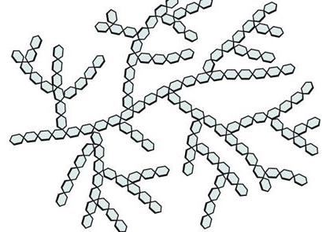
This is the energy storage molecule in animals.
It is found in granules inside the liver, or in muscle cells.
Like starch, it is made from glucose, and can be converted back into glucose via hydrolysis.
Like starch, it is joined by 1-4 glycosidic bonds, but at branches, 1-6 glycosidic bonds are used instead.
Glycogen is branched like amylopectin, but has many more branches, as this enables enzymes to quickly break down the glycogen into glucose for respiration.

